Room A
AQ1 Incarcerated Inguinal Hernia
Stem: You are consulted on a 59-year-old male. He presents with 3 days of abdominal pain, numerous episodes of bilious emesis and a visible, tender right groin mass.
PMH/PSH: with CAD s/p stent x3 in 2015, HTN, HLD, morbid obesity (BMI 43) and a history of a previously reducible right inguinal hernia.
PE: He is tachycardic to 105, otherwise vitals are stable. His abdomen distended, and TTP along the RLQ but non-peritoneal.
Labs: WBC: 11.5k. Otherwise normal.
- What is your differential diagnosis?
  - Incarcerated inguinal hernia.
  - Strangulated inguinal hernia.
  - Femoral hernia
  - Adhesive SBO
  - Infected lymph node
  - Orchitis, Testicular torsion
What test / studies do you want?
- CT scan:
- 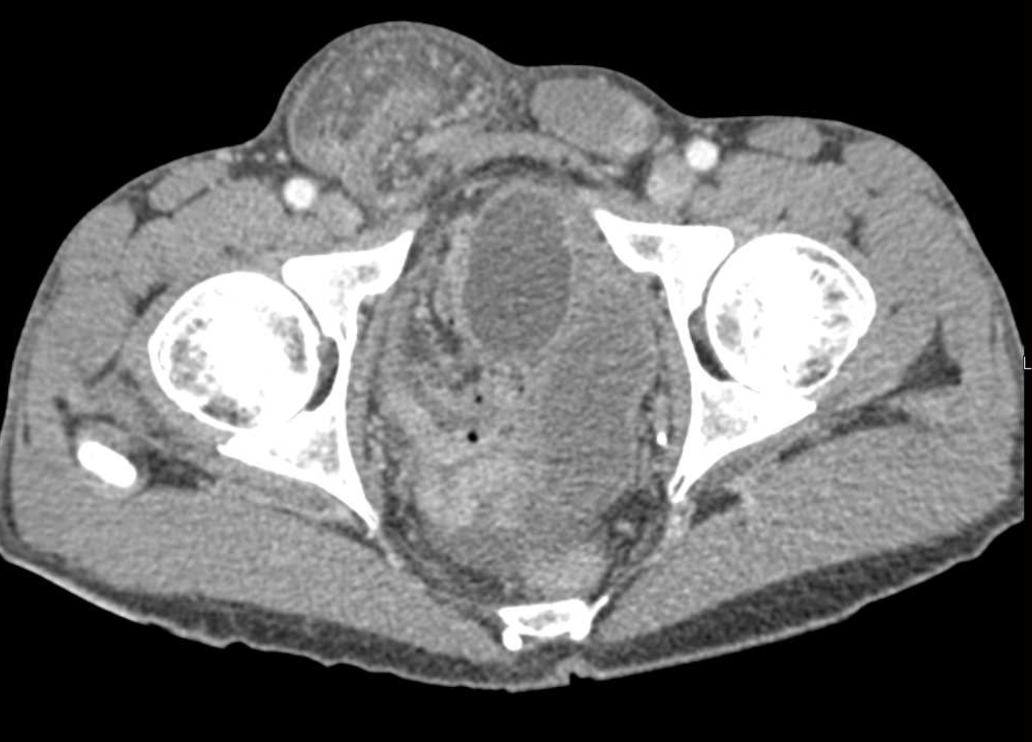
- Right inguinal hernia with bowel loops that appear enhancing and a small amount of free fluid within the hernia sac.
Now what?
- Proceed to the operating room.
What would you consent the patient for and what risks would you describe?
What Approach? (Consent should include chronic pain)
- Inguinal incision.
- Assess bowel.
  - Bowel viable but with inflammation → Reduce, repair, place mesh.
  - Bowel non-perforated but ischemic requiring resection → tissue repair vs. mesh repair are both acceptable
  - Bowel necrotic and perforated → no mesh. Should do tissue repair.

Describe your approach in inguinal hernia repair? (Resident to describe one)
- Lichtenstein:
  - Incision 1 cm above and parallel to the inguinal ligament, from pubic tubercle and extending 5-6 cm laterally.
  - The Scarpa fascia is opened.
  - The external oblique aponeurosis is opened, starting from the external ring.
  - The superior and inferior flaps of the external oblique aponeurosis are freed.
  - identify and isolate the hernia sac.
  - Reduce content.
  - polypropylene mesh is commonly used
  - The first medial most stitch fixes the mesh 2 cm medial to the pubic tubercle.
  - The same suture is then used as a continuous suture to fix the lower edge of the mesh to the free lower border of inguinal ligament.
  - a slit is made in the lateral end of the mesh
  - upper edge is then fixed to the rectus sheath and the internal oblique aponeurosis.
  - The two tails are then tucked together and fixed to the inguinal ligament just lateral to the internal ring, thus creating a new internal ring.
  - Close in layers.
- Can use plug and patch repair.
- Prolene hernia system.

Bassini repair
  - Suturing the transversalis fascia and the conjoined tendon to the inguinal ligament behind the spermatic cord with monofilament nonabsorbable suture.

Shouldice repair

The transversalis fascia is incised from the internal ring to pubic tubercle.

Upper and lower flaps are created

Flaps are overlapped (double-breasted) with two layers of sutures.

The conjoined tendon is then sutured to the inguinal ligament, again in two overlapping layers.

Scenario 2: Different patient: 85-year-old female who has a palpable, tender mass in the groin. Imaging has not been obtained. What are you concerned about?

- 1. Femoral hernia.
- Can you describe McVay/Cooper’s ligament repair?
  - The conjoined (transversus abdominis and internal oblique) tendon is sutured to the Cooper ligament with interrupted nonabsorbable sutures.
Pitfalls:
- Not taking the patient to the OR.
- Not knowing how to describe repair.
- Not knowing how to repair femoral hernia.
- Not knowing when to use mesh.

Reference: https://emedicine.medscape.com/article/1534281-technique?form=fpf#c3
AQ2 Pancreatic pseudocyst
Stem: 43-year-old man presents to your office after a recent admission 2 weeks ago for acute pancreatitis. He continues to have abdominal discomfort. RUQ ultrasound shows a fluid collection in the left upper quadrant.
Social Hx: Alcohol abuse but has abstained since admission.
Physical Exam: T=98 degrees, BP=140/60, HR 88, and RR of 18. Abdominal exam shows that he is mildly tender to palpation in the left upper quadrant without guarding or peritoneal signs.
CT scan: Shows peripancreatic inflammation, and has a 5 cm fluid collection along the pancreatic body/tail

What is your differential diagnosis?
- Pancreatic pseudocyst
- Serous cystadenoma
- IPMN
- Mucinous cystadenoma

What would you like to do now?
- Wait and watch. (Pseudocysts can develop in up to 10% of patients with acute pancreatitis. Majority will spontaneously resolve)

Scenario: Patient returns to office 2 months later with persistent symptoms of early satiety, nausea and occasional emesis. CT scan now shows 15 cm pancreatic body/tail cyst with thickened wall and compression of stomach. What to do now?
1. MRI/MRCP
2. Drainage:
- Internal drainage with cystgastrostomy – endoscopic vs surgical.
3. Surgical cyst gastrostomy (open or lap). Describe open cystgastrostomy?
- Upper midline.
- cholecystectomy
- anterior gastrostomy, expose posterior wall.
- enter cyst through posterior wall.
- biopsy.
- Debride necrosis.
- Anastomosis, wide at least 5 cm.

If patient has splenic or portal vein thrombosis what are you concerned about?
Perigastric varices can preclude cyst gastrostomy.

Scenario: Original patient with pancreatic pseudocyst gets admitted to hospital with abdominal pain, fever, and leukocytosis. What to do now?
- CT scan with IV contrast:

CT shows Multiple pockets of air within pseudocyst cavity. Patient becomes hypotensive and is transferred to ICU. He continues to worsen clinically and is now intubated and on pressors. How to proceed?
- IV Abx
- Abscess cavity drainage.
- Pancreatic necrosectomy. Can you describe the complications of this approach?
  - Bleeding
  - Pancreatic duct leak
  - Pancreatic fistula
  - EC fistula

Pitfalls:
- Not knowing when to drain pseudocyst.
- Not knowing signs of infection and how to treat.

Reference: https://www.ncbi.nlm.nih.gov/books/NBK557594/

AQ3 Abdominal Pain After Colonoscopy and Polpectomy
Stem: 55y male presenting to ED, You, 4 hours earlier, done a colonoscopy and removed two adenomatous polyps, they were removed without difficulty and were benign looking . Patient is now with left lower quadrant abdominal pain, nausea, and inability to tolerate oral intake.
PE: Vitals: Tmax of 37.8, HR 90, BP 120/70. Abdomen is mildly distended but no guarding or rigidity, focal tenderness in the left mid and lower abdomen.
Labs: Labs: CBC, BMP: WBC 15000, Hb 14, BMP No significant defragments.

ER physician calls you to admit the patient, and ask if you want any imaging done?
- 2. CT scan abd/pelvis:
  - Small volume pneumoperitoneum around the sigmoid colon, no fluid collections or bowel thickening.

What is your differential diagnosis?
- Perforation at polypectomy site
- Perforation elsewhere from colonoscopy
- Retained gas in colon causing pain.
- Splenic injury

What would you like to do now?
- Admit
- Non-op management if no peritonitis
  - NPO
  - IV antibiotics.
  - Serial abd exams
b. OR if worsened exam or vital signs.
- Start with diagnostic laparoscopy, can do primary repair if small defect, minimal spillage, healthy colon surrounding.

Scenario: What if patient comes in 10 hours after colonoscopy with complaints of diffuse abdominal pain, tachycardia to 110s, fever, and WBC of 19? ER physician calls you and said we got this abdominal x-ray
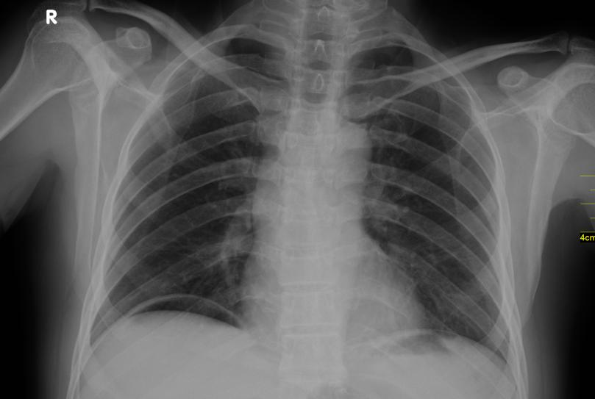
Now what?

- OR for ex lap.
Your patient is hemodynamically normal through the case, you suction some free fluid, looks like bowel prep. How would you repair the perforation?
- Primary repair
- Vs resection with anastomosis +/- diversion

(Resident must be able to realize ability to offer primary anastomosis in hemodynamically stable patient , resident can divert their anastomosis / preferable over Hartman’s )

What if the site of the polypectomy/biopsy was highly suspicious for colon cancer and now presents with peritonitis, fever, and tachycardia. You are already in the OR and you perforation at tumor site where you biopsied, what to keep in mind while performing resection?

Oncologic resection / anastomosis if able (high ligation of vessels). +/- diversion. (Depending on the location of the tumor, and the location of the perforation)

Scenario 2: Same patient presents 36 hours after hot snare polypectomy of 1cm lesion in the ascending colon with abdominal pain in the right hemiabdomen, focal guarding in the right mid abdomen, and mild leukocytosis of 13000. CT demonstrates thickening of small segment of ascending colon, no pneumoperitoneum or free fluid.
What is your Diagnosis ?
- Postpolypectomy syndrome.

How would you manage it?
  - NPO
  - IVF
  - IV antibiotics then PO abx.

Scenario 3: Same patient presenting 4 hours post colonoscopy after passing out at home while attempting to stand, and complaining of significant left sided abdominal pain that is now more diffuse.
He’s tachycardic to 115, BP 100/80, hemoglobin 9 from 14 pre-procedure. Exam reveals distention of the abdomen and diffuse guarding.
What is your differential diagnosis?
  - splenic laceration.
  - Hemorrhage from polypectomy site.

CT demonstrates splenic laceration with active extravasation and hemoperitoneum. How would you manage?

- IVF
- Type and cross
- Transfuse if becomes unstable.
- OR for ex lap, splenectomy vs. IR embolization.

Pitfalls:
- Not knowing the differential diagnosis.
- Not knowing post polypectomy syndrome and management.
- Should be able to consider anastomosis if hemodynamically stable.
- Not knowing risk of splenic laceration after colonoscopy.

Reference: https://www.asge.org/docs/default-source/education/practice_guidelines/doc-56321364-c4d8-4742-8158-55b6bef2a568.pdf

